Button Type
We have an option to add multiple buttons(each button can be linked with a separate card)
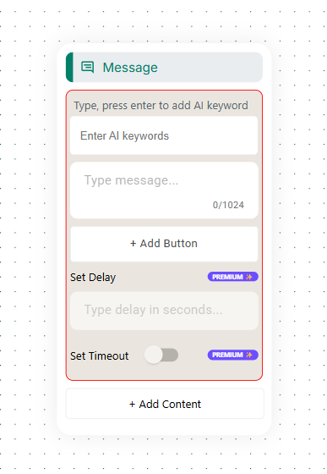

Media Type
Media button to add - Image/Video/Audio/File, it also has an option to add multiple buttons
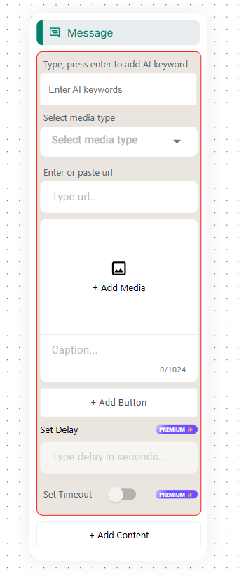

List Type
Option to add a common header, body, footer. Then create sections and each section can have multiple items(each allowing title and description)
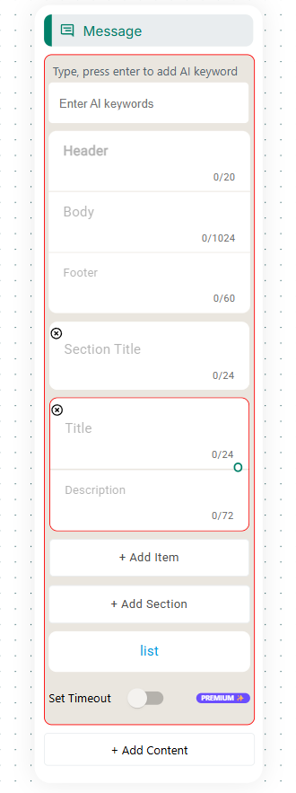

Catalogue Message Type
Not sure what this is used for
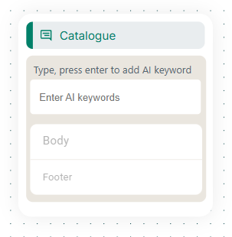

Single Product Type
It allows us to pick a product and add body and footer
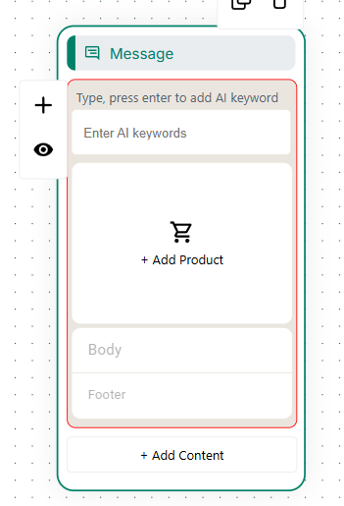

Multiple Products
We have an option here to create multiple sections and attach each section with multiple products from our catalogue.
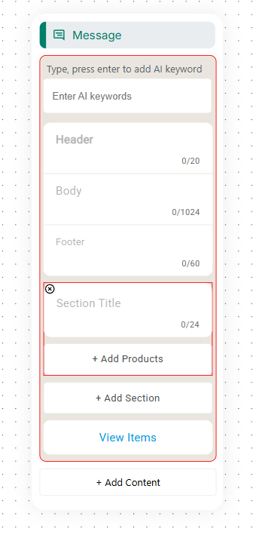

Template Type
We have an option here to choose a template
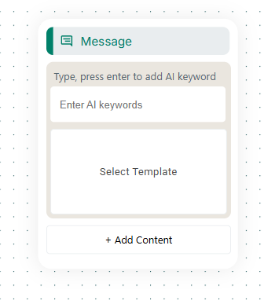

Add content function to each Type
So below we have a button type with media type added to that node
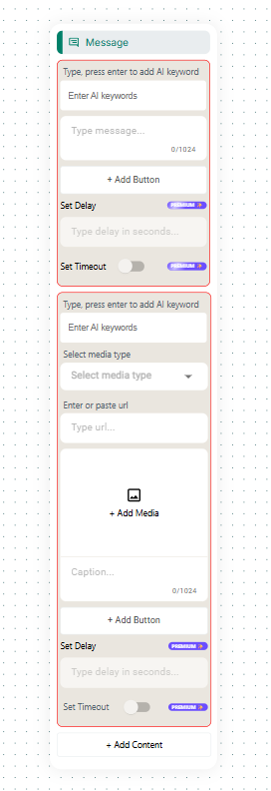

Request Intervention Action
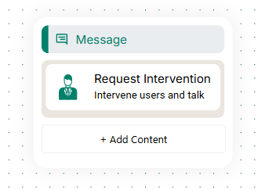

Condition Action
Condition can be equal, exists, time in, date in. with attribute selection
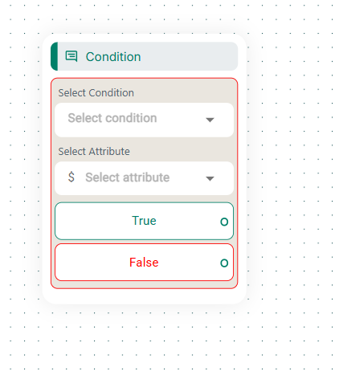

Connect Flow Action
We have an option here to select a pre existing flow
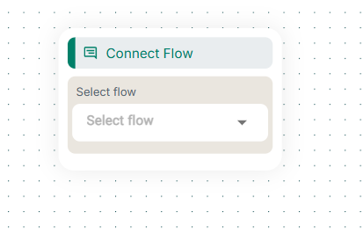

Ask Address Action
Here we also have an option to select attribute, and select attribute for formatted response
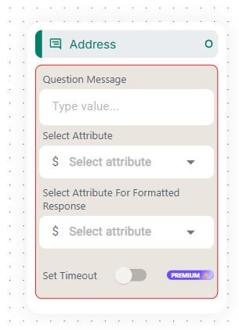

Ask Location Action
Similar form fields like Ask Address
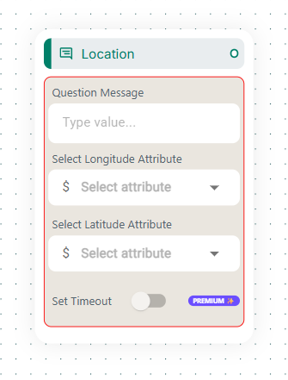

Ask Question Action
Type a question and capture answer attribute, the attribute form can be any,text,number,date,true/false,email,regex
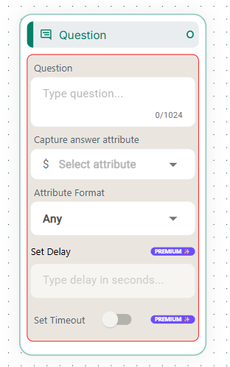

Ask Media Action
Media can be image/audio/video/file; not sure what attemps mean here. We also have validation errors
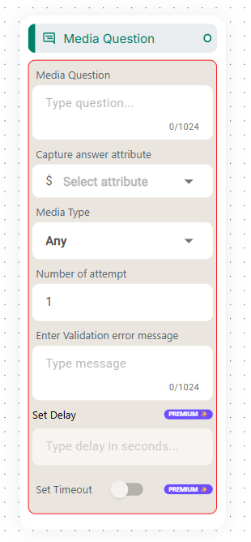

Set Attribute Action
Sets a value of an attribute from the select
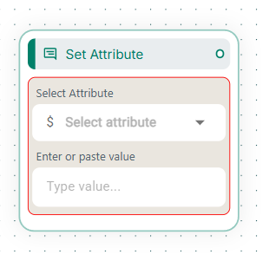

Tag Action
Probably this is used to select a tag ina flow, or to create or create a tag directly for usage
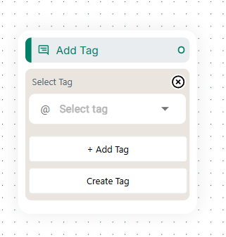

API Actions
WE have an option to add webhook url, status fallback, we can also define our own status code
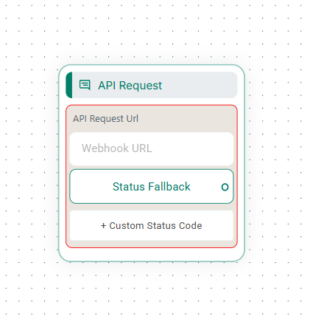

Tags May be trackable across the user journey

